Annotation to project work
Name of project work: “Use of Solar Energy for the Needs of Hot Water Supply at Jsc ‘Babushkina Krynka”- Managing Company of Holding “Mogilev Dairy Company “Babushkina Krynka”
Mark with cross the thematic area and highlight the topic with blue colour:
( ) Building, for example, insulation, window replacement, construction of a new energy efficient building
( ) Electric energy, for example, lighting, compressed air, electric drives, refrigerating machines, load management
( ) Heat, for example, heating, industrial heat, heat return, ventilation / air conditioning technology, cogeneration
(Х) Renewable sources of energy, for example, solar technology, wood energy, biogas, geothermal energy
( ) Management, for example, energy purchase, contracting, emission trading, energy resources data management system
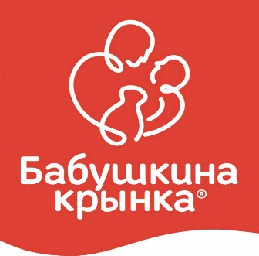 |  | Company: Jsc ‘Babushkina Krynka”- Managing Company of Holding “Mogilev Dairy Company “Babushkina Krynka”  Industrial sector: food industry  Products/services: dairy products  Number of staff: 1100  Name and surname of the author of the project: Denis Izoh  Participant of EUREM courses №: 1  Contact information: +375 29 852 88 55  izoxdenisalex@gmail.com

Description of the project: The use of solar energy to generate thermal energy for the needs of hot water supply instead of the heat supplied from the enterprise boiler-house.

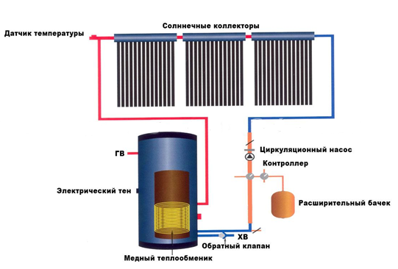
Results:
Energy safety potential (kWh / year):  802.000  Energy material: hot water  Costs saving potential (euro/year):  13.969  potential for СО₂ emission reduction (tonne/year): 186 t. | Investment costs (euro): 99.946  Payback period (years): 7,2  Probability of implementation:  ( ) high ( ) medium (Х) low

